Mirroring foreign affiliate statistics - what do we see?
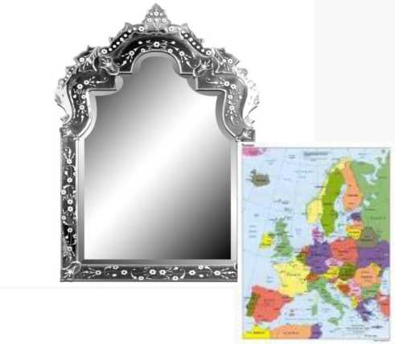
Lise Dalen Mc Mahon, Statistics Norway GVC Workshop, Copenhagen 27 November 2013

What will I talk about
- Aim of the study
- Approach
- Main findings
- Recommendations, challenges and lessons learned

What should we ideally see
• Inward FATS (IFATS): foreign controlled enterprises resident in the country that compiles the statistics
• Outward FATS (OFATS): enterprises controlled by the compiling country, but resident abroad
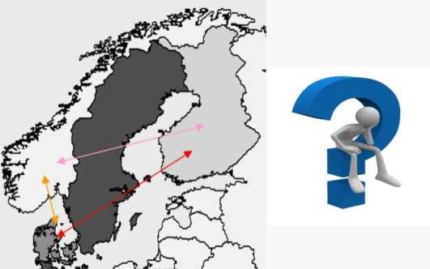

• Residency of the ultimate controlling institutional unit (UCI) defines the nationalities of enterprises in both statistics

Why do we want a mirror reflection?
•Foreign affiliates contribute to a host country’s international competitiveness and welfare
•And provides access to new markets and new technologies for domestic suppliers and buyers along the value chain
•Foreign affiliates statistics is used in economic research to measure the degree of globalisation
- Cf. the economic globalisation indicators just presented
- Are also used in international trade negotiations

What did we want to achieve?
• Test possible methods of improving the quality of FATS
- by utilising information available within the European Statistical System (ESS) related to the population of foreign affiliates
• To see if we can improve the data quality and maybe reduce resources needed
- By exchanging information about Nordic owned affiliates in Denmark, Finland and Norway
- Come up with recommendations on future ways for improving FATS- statistics in the ESS

Approach of comparison
• Main question when linking the foreign outward FATS with the domestic inward FATS - Are the frame populations identical?
• We set up an approach to compare the OFATS data with sources of information available nationally
- Business register, enterprise group register and inward FATS
- Individual records were linked using the name of the enterprise

Looking in the mirror - the overall reflection
• 1368 OFATS enterprises and 1877 IFATS enterprises
- i.e. reflection cannot be perfect
- Identical enterprise with same UCI determination: 781
• Differences can be separated into two groups
- Enterprises only found in one of the statistics:
- 587 enterprises in OFATS
- 1096 enterprises in IFATS
- Identical enterprise, but IFATS has a different UCI determination than the OFATS country:
- 130 enterprises

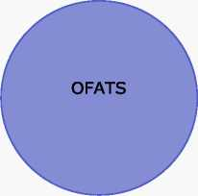
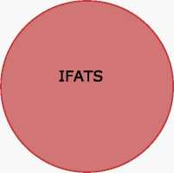
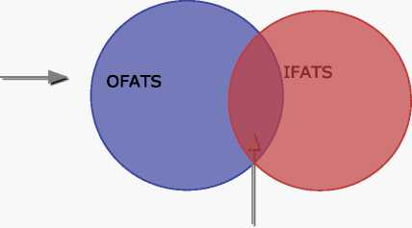
Overall results 1)
1.368 (enterprises in OFATS) 62.442 (employees in OFATS)
1.877 (enterprises in IFATS) 86.603 (employees in IFATS)
587 (enterprises only in OFATS) 23.460 (employees only in OFATS)
1.096 (enterprises only in IFATS) 47.041 (employees only in IFATS)
781 identical enterprise 38.982 (OFATS employees) 39.562 (IFATS employees)

Overall results 2)
 | IFATS
UCI | Enterprise | Employees
Domestically owned | 77 | 1 758
AE | 3 | 906
AT | 1 | 33
AU | 1 | 3
BE | 2 | 99
CH | 2 | 23
DK* | 1 | 1
DE | 2 | 5
EE | 1 | 2
ES | 1 | 0
FI* | 1 | 9
FR | 1 | 28
IS | 1 | 38
GB | 5 | 108
LU | 1 | 14
NL | 1 | 164
NO* | 1 | 9
SE | 15 | 939
US | 13 | 82
Total | 130 | 4 221

Looking in the mirror: same activity?

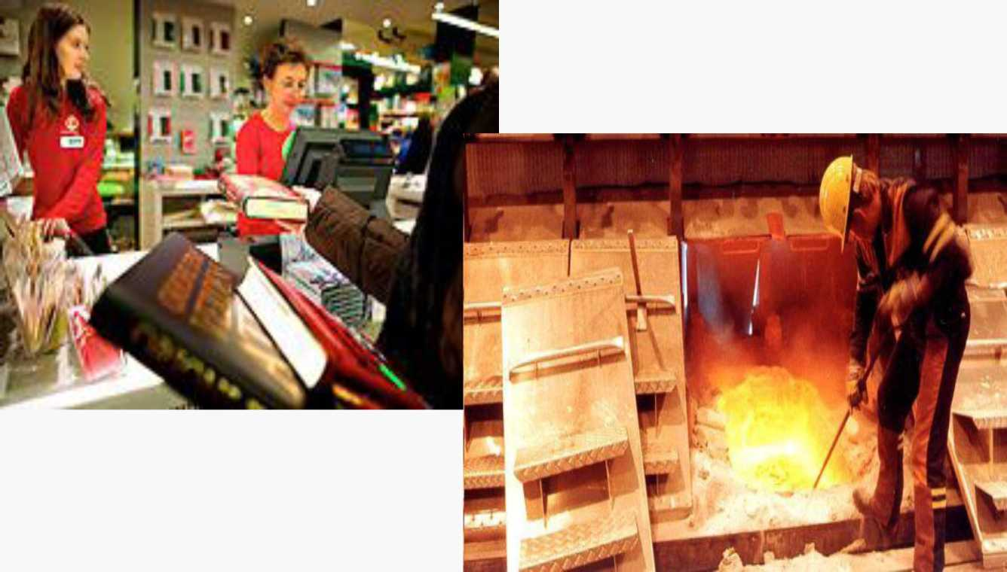

Looking in the mirror: same activity?
NACE  2.0 | TOTAL | OFATS  A | OFATS  B | OFATS  C | OFATS  D | OFATS  E | OFATS  F | OFATS  G | OFATS  H
TOTAL | 447 | 0 | 5 | 100 | 5 | 0 | 10 | 86 | 66
IFATS  A | 0 | 0 | 0 | 0 | 0 | 0 | 0 | 0 | 0
IFATS  B | 2 | 0 | 0 | 1 | 0 | 0 | 1 | 0 | 0
IFATS  C | 57 | 0 | 1 | 49 | 0 | 0 | 1 | 2 | 0
IFATS  D | 6 | 0 | 0 | 0 | 5 | 0 | 0 | 0 | 0
IFATS  E | 0 | 0 | 0 | 0 | 0 | 0 | 0 | 0 | 0
IFATS  F | 10 | 0 | 0 | 2 | 0 | 0 | 4 | 2 | 0
IFATS  G | 165 | 0 | 0 | 41 | 0 | 0 | 1 | 74 | 44
IFATS  H | 16 | 0 | 0 | 0 | 0 | 0 | 0 | 0 | 14

Looking in the mirror: Employing same amount of persons?
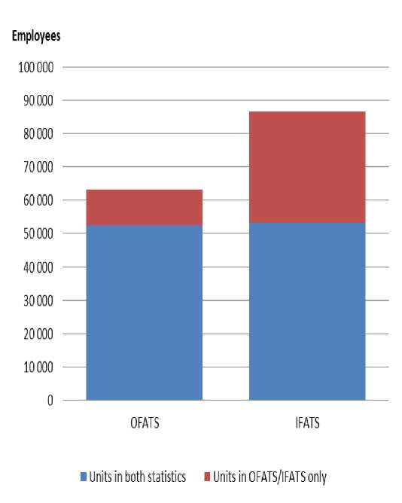
•Employed persons in the OFATS are always less than in the IFATS
•The differences in employed persons are mainly due to missing affiliates (red parts of the bar) •Where both O/I FATS cover the same affiliates (the blue part) figures are fairly equal

What does the EGR say?
• For the 781 identical enterprise with same UCI determination:
- 284 enterprises are found in the EGR
• For the 130 identical enterprise where IFATS has a different UCI determination than the OFATS country:
- 27 can be found in the EGR

Main findings in the study
- Differences between the employee numbers of O/IFATS :
- are mainly due to affiliates missing from them
- Differences in activity codes O/IFATS:
- enterprises are on average placed in the same activity code
- the biggest deviations where found in activity code G, Wholesale and retail trade
• Agreement on the UCI is central to improving the quality of both IFATS and OFATS

Recommendations
• Alternative 1: Use the EuroGroupRegister (EGR) to improve FATS statistics
- Alternative 2: Bi- or multilateral cooperation with other NSIs
• Both methods have the common challenge on how to agree on the UCI
- Clarify the guidelines for determining the UCI in the FATS manual
• Important to have a legal framework for exchange of data in place

